Lab 7: Learning Basic Features of Docker
Theory:
Docker is an open-source containerization platform that allows developers to package applications along with their dependencies into lightweight, portable containers. Containers ensure consistency across different environments such as development, testing, and production.
Microsoft Azure is a cloud computing platform that provides services such as virtual machines, networking, storage, and container services. Azure supports Docker natively, allowing users to deploy, manage, and scale containerized applications easily.
Using Docker in Azure Cloud helps in faster application deployment, better resource utilization, scalability, and simplified DevOps practices.
Steps:
- Install Docker from your Ubuntu VirtualBox terminal and verify whether it is running or not
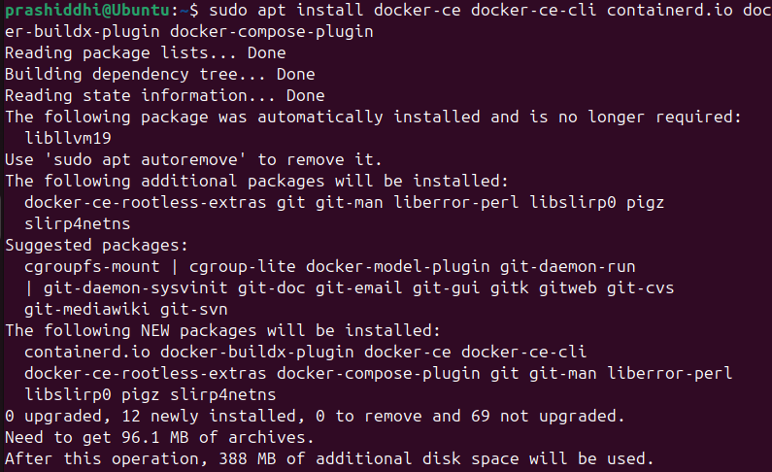
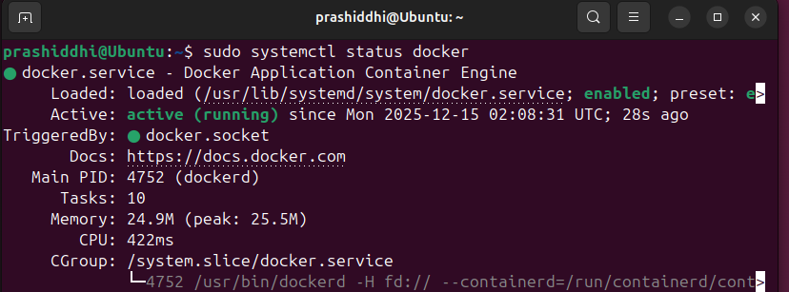
- Pull docker image and run it
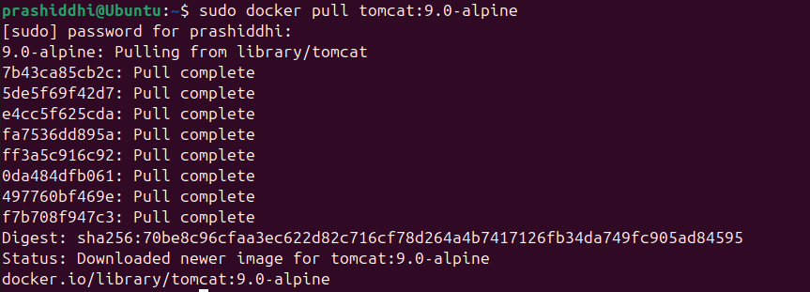
- Check active docker in windows along with images
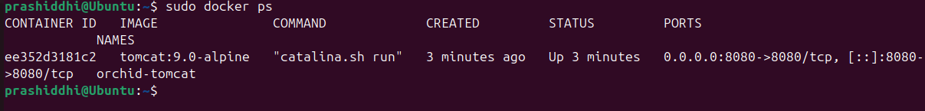


- Check Docker Logs
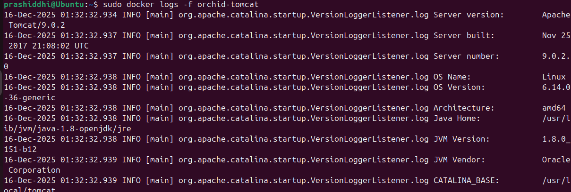

- Inspect Docker
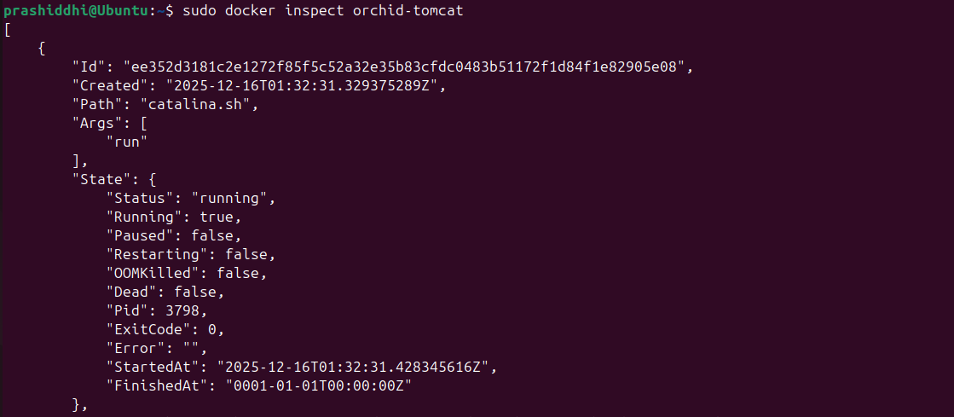

- Check your IP through the command ip a
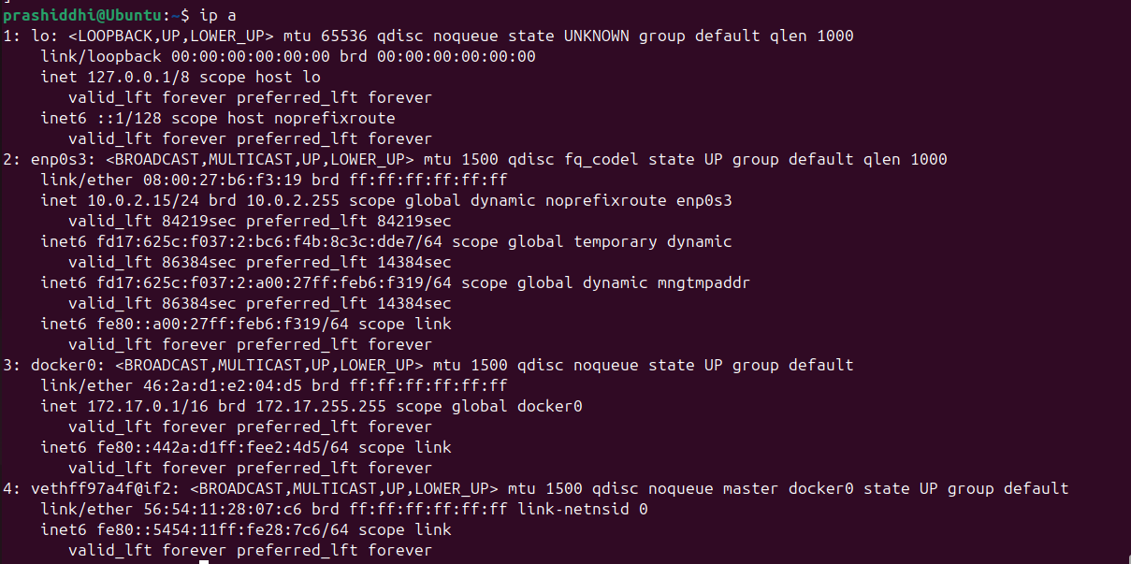
In our case the IP is 10.0.2.15.

- Run the IP in your browser and verify if it shows the default welcome page of Apache Tomcat 9.0.2 to verify a successful installation
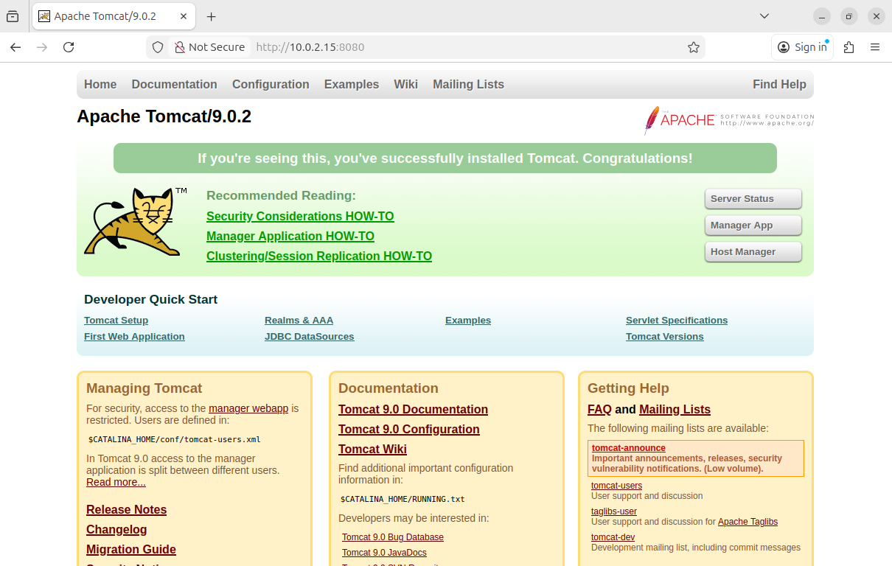

- Demonstrate Docker container lifecycle management by stopping, verifying the stopped state, restarting, and confirming the 'orchid-tomcat' container is running again.

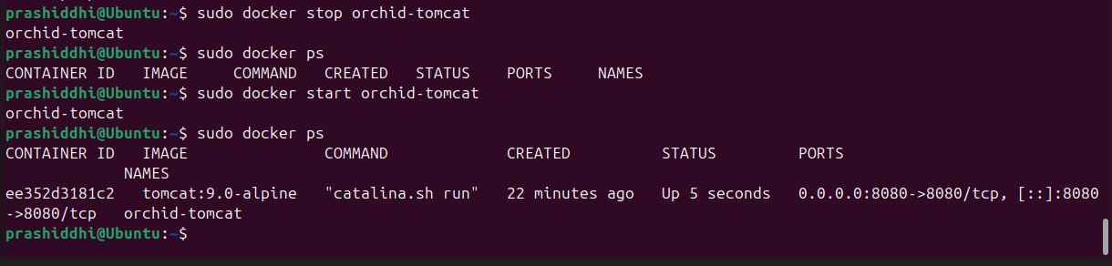

Result and Conclusion

Result: The Apache Tomcat Docker image (tomcat:9.0-alpine) was successfully pulled from Docker Hub. A Docker container named orchid_tomcat was created and executed on the Azure Virtual Machine. The Tomcat server was accessed successfully through the browser using the VM’s public IP address and port 8080.

Conclusion: This lab successfully demonstrated the basic features of Docker in the Azure Cloud environment. Pulling and running the Apache Tomcat container showed how containerized applications can be deployed efficiently on cloud infrastructure. Docker combined with Azure provides a reliable, scalable, and flexible platform for modern application deployment.

